Apache Airflow
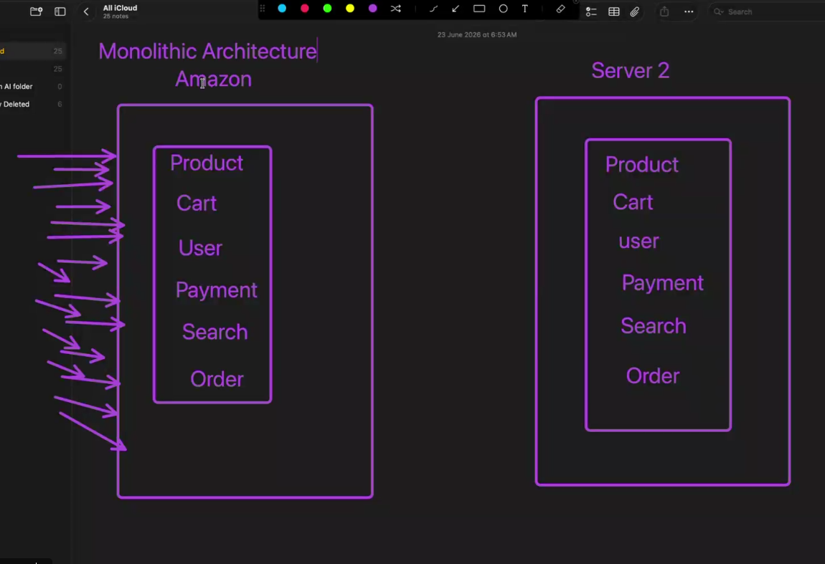
Apache Airflow Workflow Orchestration using Docker and KillerCoda
Apache Airflow is an open-source workflow orchestration platform developed by Airbnb and currently managed by the Apache Software Foundation. It is designed to programmatically author, schedule, and monitor workflows. Airflow enables organizations to automate complex data pipelines and manage task dependencies efficiently.
In this project, Apache Airflow was deployed using Docker in the KillerCoda Ubuntu environment. A sample DAG was created and executed to demonstrate workflow orchestration and task scheduling.

What is Apache Airflow?
Apache Airflow is a platform used to automate, schedule, and monitor workflows. Workflows are represented as Directed Acyclic Graphs (DAGs), where each task is represented as a node and dependencies are represented as edges.
Airflow allows developers and data engineers to define workflows using Python code, making it highly flexible and customizable.
Key Features
- Workflow Scheduling
- Task Dependency Management
- Retry and Failure Handling
- Monitoring and Logging
- Scalable Architecture
- Python-Based Development
- Web-Based User Interface
- Integration with Cloud Platforms and Databases
Real-World Applications
- ETL Pipelines
- Data Warehousing
- Machine Learning Workflows
- Report Automation
- Cloud Data Processing
- Batch Data Processing
Why Apache Airflow Instead of Azure Data Pipelines?
Azure Data Factory and Azure Data Pipelines are cloud-native orchestration services, while Apache Airflow provides greater flexibility and customization.
Comparison
Apache Airflow
- Open-source platform
- Python-based workflow creation
- Highly customizable
- Supports multi-cloud environments
- Extensive community support
- Easy integration with third-party tools
Azure Data Pipelines
- Managed Azure service
- Graphical user interface
- Limited customization compared to code-based workflows
- Primarily designed for Azure ecosystem
- Subscription-based pricing
Advantages of Airflow
- Open-source and free to use.
- Workflows are defined using Python code.
- Supports complex task dependencies.
- Easy monitoring and debugging.
- Can run on-premises or cloud environments.
- Supports integration with AWS, Azure, GCP, Databases, and APIs.

What is a DAG?
DAG stands for Directed Acyclic Graph.
A DAG is the fundamental building block of Apache Airflow. It defines the workflow, tasks, and execution order.
Directed
Tasks follow a specific direction from start to end.
Acyclic
Tasks cannot create circular dependencies.
Graph
A collection of tasks connected through dependencies.
Example DAG
Extract Data
↓
Transform Data
↓
Load Data
In this workflow:
- Extract task executes first.
- Transform task executes after Extract.
- Load task executes after Transform.
Benefits of DAGs
- Clear workflow visualization
- Task dependency management
- Easier monitoring
- Workflow automation
- Error handling and retries

Apache Airflow Architecture
Apache Airflow consists of several components:
Web Server
Provides the Airflow User Interface (UI) for monitoring and managing workflows.
Scheduler
Monitors DAGs and determines when tasks should be executed.
Executor
Executes the tasks assigned by the scheduler.
Metadata Database
Stores DAG information, task states, execution logs, and workflow metadata.
Workers
Execute workflow tasks when distributed execution is configured.
DAG Files
Python scripts that define workflows.
Architecture Flow
User → DAG File → Scheduler → Executor → Worker → Database → Airflow UI

Environment Setup
Platform Used
- KillerCoda Ubuntu Environment
- Docker Containerization
- Apache Airflow Latest Version
Docker Installation Verification
docker --version
Running Airflow Container
docker run -d \
-p 8080:8080 \
--name airflow \
apache/airflow standalone
Explanation
- docker run : Creates a new container
- -d : Runs container in detached mode
- -p 8080:8080 : Maps Airflow UI to port 8080
- --name airflow : Assigns container name
- apache/airflow standalone : Runs Airflow standalone mode

Verifying Container Status
docker ps
Expected Result:
Container status should display "Up".

Accessing Airflow Logs
docker logs airflow
The logs display:
- Airflow initialization
- Database creation
- Admin user creation
- Scheduler startup
- Webserver startup

Accessing Airflow UI
After successful startup:
http://localhost:8080
Login credentials are generated automatically and displayed in the logs.
Dashboard Features
- DAG Monitoring
- Task Status Tracking
- Execution History
- Graph View
- Gantt Charts
- Task Logs

Creating First DAG
A sample DAG was created to demonstrate workflow execution.
Workflow Logic
Task:
Print "Hello from Airflow"
DAG Components
- DAG Definition
- Python Operator
- Task Dependency
- Schedule Configuration
Execution Steps
- Create DAG file.
- Save DAG in DAGs folder.
- Refresh Airflow UI.
- Enable DAG.
- Trigger DAG execution.
- Monitor task execution.
- Verify logs.

DAG Execution Flow
Start
↓
Hello Task
↓
Success
The DAG executed successfully and the task logs confirmed execution.

Monitoring DAG Execution
Airflow provides multiple monitoring options:
Graph View
Displays task dependencies.
Grid View
Displays execution history.
Logs
Displays task output and execution details.
Gantt View
Displays task duration and timing.

Benefits Achieved
- Automated workflow execution
- Centralized monitoring
- Task dependency management
- Error handling capabilities
- Reusable workflow definitions
- Scalable orchestration framework

Learning Outcomes
Through this project, the following concepts were learned:
- Apache Airflow Fundamentals
- Workflow Orchestration
- DAG Creation and Management
- Docker Container Management
- Task Scheduling
- Workflow Monitoring
- Airflow Architecture
- Logging and Debugging
- ETL Workflow Automation

Task Sample code:
cat > first_dag.py
from airflow.sdk import DAG
from airflow.providers.standard.operators.python import PythonOperator
from datetime import datetime
def task1_function():
print("Task 1 Started")
def task2_function():
print("Task 2 Running")
def task3_function():
print("Task 3 Completed")
with DAG(
dag_id="first_training_dag",
start_date=datetime(2025, 1, 1),
schedule="@daily",
catchup=False,
tags=["training"]
) as dag:
task1 = PythonOperator(
task_id="task1",
python_callable=task1_function
)
task2 = PythonOperator(
task_id="task2",
python_callable=task2_function
)
task3 = PythonOperator(
task_id="task3",
python_callable=task3_function
)
task1 >> task2 >> task3
Ctrl + d — Save
ls
airflow config get-value core dags_folder

airflow dags list-import-errors

airflow dags reserialize

airflow dags list

Short Notes
What is Apache Airflow?
Apache Airflow is an open-source workflow orchestration tool used to create, schedule, monitor, and automate data pipelines. It allows workflows to be defined using Python code and executed based on dependencies.
Short Answer:
"Apache Airflow is a workflow orchestration platform used to automate and manage data pipelines through DAGs."
Why is Apache Airflow Used?
Apache Airflow is used to automate repetitive tasks, manage workflow dependencies, schedule jobs, and monitor data pipelines efficiently.
Short Answer:
"Airflow is used to automate, schedule, and monitor workflows and ETL pipelines."
What is a DAG?
DAG stands for Directed Acyclic Graph. It is the core component of Airflow that defines tasks and their execution order.
Short Answer:
"A DAG is a workflow definition in Airflow that represents tasks and their dependencies."

